

Mobile Programming
Course Project Report

– Hanoi, Mar 2026 –
Table of Contents
I. Project Overview 5
1.1. Project Information 5
1.2. Project Team 5
1.3. Product Background 5
1.4. Major Features 6
1.5. Tools & Infrastructures 7
II. Software Requirement Specification 7
1. Overall Requirement 7
1.1 Context Diagram 7
1.2 Main Workflows 8
1.3. User Requirements 9
1.3.1 Actors 9
1.3.2 Use Case List (UC) 9
1.3.3 Use Case Diagrams 10
1.3.3.2 UCs for Customer 12
1.3.3.3 UCs for Admin 13
1.4 System Functionalities 14
1.4.1 Screens Flow 14
1.4.2 Screen Authorization 14
1.4.3 Non-UI Functions 15
1.5 Entity Relationship Diagram 15
2. Use Case Specifications 16
2.1 Admin & Customer Features 16
2.1.1. Login 16
2.1.2. Register 17
2.1.3. Forgot Password 17
2.1.4. Change Password 18
2.1.5. View Profile 18
2.1.6. View Guides 19
2.1.8. Update guide 19
2.1.9. Delete Guides 20
2.1.10. View Author Detail 21
2.3 Plan Location 21
2.3.1. View Plan List 21
2.3.2. Add Plan Information 22
2.3.3. Delete Plan 22
2.4 Tour Management Features 23
3. Non-Functional Requirements 28
3.1 External Interfaces 28
3.2 Quality Attributes 28
3.2.1 Usability 28
3.2.2 Reliability 28
3.2.3 Performance 29
3.2.4 Security 29
4. Requirement Appendix 29
4.1 Business Rules 29
4.2 Common Requirements 30
4.3 Application Messages List 30
III. Software Design 32
1. High Level Design 32
1.1 Software Architecture 32
1.2 Package Diagram 32
2. Database Design 34
2.1 Database diagram 34
2.2.Table Descriptions 34
2.2.1 locations 34
2.2.2 plans 35
2.2.3. Plan_items 35
2.2.4 the_100_categories 36
2.2.5 tours 36
2.2.6 tour_features 37
IV. Implementation 38
4.1. Login Flow 38
4.2. Homepage and Viewing Tour List 39
4.3. Tour Detail 40
4.4. Add Tour to Plan 42
4.5. Tour Completion 43

I. Project Overview

1.1. Project Information
- English name: Culture Trip App
- Vietnamese name: Ứng dụng chuyến đi văn hóa
- Team name: PRM393 - Group 3
- Software type: Mobile Application (Android/iOS)

1.2. Project Team
StudentID | Full Name | Role
HE186352 | Nguyễn Văn Đức | Leader
HE181585 | Trần Ngọc Dũng | Member
HE181196 | Đỗ Đắc Huy | Member
HE181929 | Nguyễn Hoàng Việt | Member
HE181653 | Nguyễn Tiến Duy | Member

1.3. Product Background
In today's digital age, the need to explore new lands and diverse cultures is rapidly increasing. However, travelers often face "information fragmentation," where finding reputable travel companies, reading professional travel guides, and organizing personalized itineraries requires the use of multiple disparate platforms. This fragmented process not only leads to information overload but also makes it difficult for users to maintain a consistent and organized plan for their trip.
The Culture Trip App centralizes curated exploration (Top 100), expert travel destination guides from previous travelers, and global tour management into a single intuitive interface. By allowing users to explore, research, and save their favorite tours or destinations directly into a structured "My Plan" feature, this project aims to transform complex travel information discovery into a seamless and enjoyable adventure.

1.4. Major Features
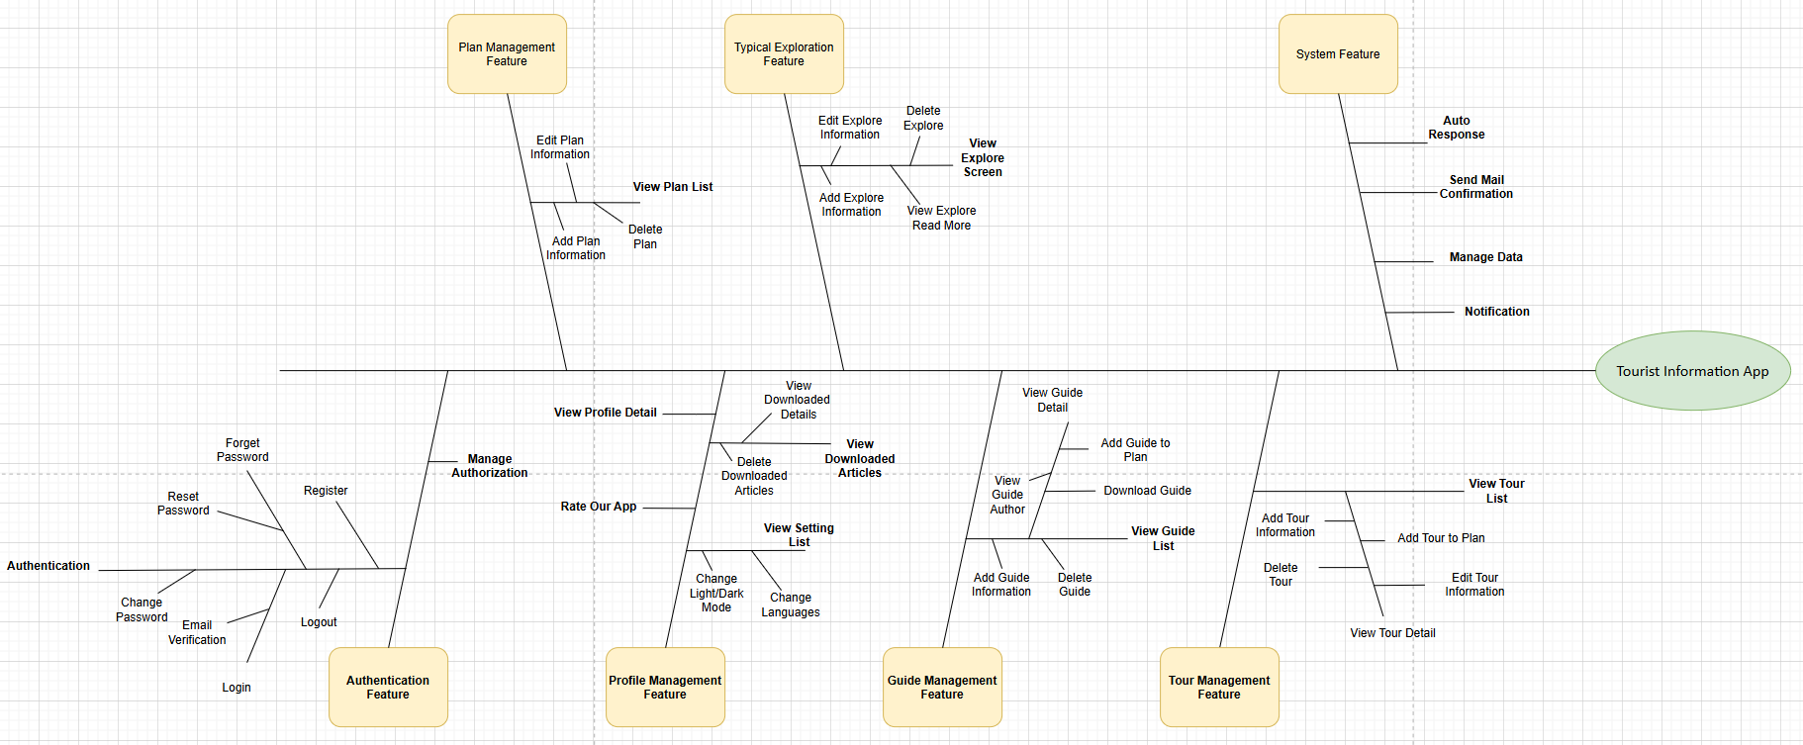

FE-01: Authentication Feature - Manages user authentication including login, registration, password reset/change, and email verification via Firebase.
FE-02: Profile Management Feature - Enables users to view profile details and adjust app settings such as light/dark mode, language selection, and view downloads.
FE-03: Guide Management Feature - Allows users to browse travel guides, view author information, download guides for online access, marking guides to plans and provides administrative features to manage guide content.
FE-04: Tour Management Feature - Manages tour discovery across continents including viewing itineraries, pricing, marking tours to plans.
FE-05: Plan Management Feature - Provides features to create, edit, or delete personal travel plan folders and handles local data persistence via SQLite for itinerary management.
FE-06: Typical Exploration Feature - Offers discovery of top global destinations through typical list, providing in-depth articles and management of featured locations.
FE-07: System Feature - Manages automated system functions including auto-response messages, sending mail confirmation, notification and local database backup/data management.

1.5. Tools & Infrastructures

Category | Tools / Infrastructure
Technology | Flutter Framework, Dart Language
Database | Firebase (Authentication), SQLite (Local Storage)
API | Firebase Auth API, Google Sign-in API
IDEs/Editors | Android Studio
Diagramming | draw.io
Documentation | Google Docs
Version Control | Git
Deployment server | None
Test tool | None
Project management | GitHub, Zalo, Excel, Notepad

II. Software Requirement Specification

1. Overall Requirement

1.1 Context Diagram

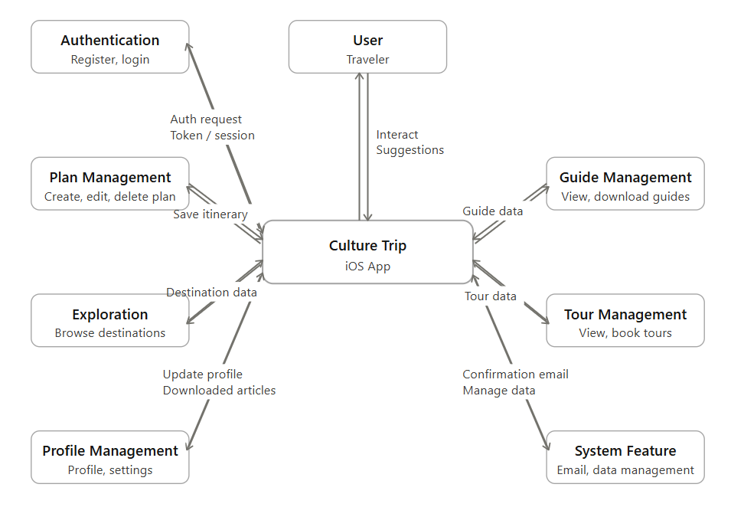

1.2 Main Workflows
App khởi động Firebase + Riverpod → Splash kiểm tra session → vào Main (6 tab) hoặc Login → người dùng duyệt nội dung du lịch chủ yếu từ SQLite; tài khoản qua Firebase; Guides/Home là nơi CRUD location/guide và gắn với Plans.

1.3. User Requirements

1.3.1 Actors
# | Actor | Description
1 | Guest | An unregistered or unauthenticated visitor. They have restricted access, allowing them only to browse public content such as the home page, guides, authors, and tours. They cannot create travel plans or modify any system data.
2 | Customer | A registered and logged-in user. In addition to guest privileges, they can manage their personal profile, change their password, and fully manage their personal travel plans (view, create, edit, delete).
3 | Admin | The system administrator. They have the ability to manage their own account and hold full privileges to add, edit, and delete core application content, including Guides, Guide Details, Tours, and Tour Details.

1.3.2 Use Case List (UC)
ID | Use Case | Features | Actor | Use Case Description
01 | Login | Authentication Management | Customer, Admin | Allows unauthenticated users and admins to securely log into the system.
02 | Register |  | Customer, Admin | Allows a new guest to create a customer account.
03 | Forgot password |  | Customer, Admin | Sends an OTP or reset link to recover a forgotten password.
04 | Change password |  | Customer, Admin | Allows logged-in users to update their password in the settings menu.
05 | Logout |  | Customer, Admin | Allows authenticated users to securely sign out of the system.
06 | View Profile |  | Guest, Customer, Admin | Allows users to view/update personal information and sync data online/offline.
07 | Home | General View | Guest, Customer, Admin | Displays the main navigation interface and dashboard.
08 | View Guides | Guides & Authors | Guest, Customer, Admin | Displays a list of available guide articles
09 | Add Guide |  | Admin | Allows admins to create and publish a new guide article.
10 | Edit Guide |  | Admin | Allows admins to modify the general information of an existing guide.
11 | Delete Guide |  | Admin | Allows admins to remove a guide article from the system.
12 | View Guide Detail |  | Guest, Customer, Admin | Displays the in-depth content and specific details of a guide.
13 | Add Guide Detail |  | Admin | Allows admins to add specific sections or detailed components to a guide.
14 | Edit Guide Detail |  | Admin | Allows admins to modify existing detailed components of a guide.
15 | View Author |  | Guest, Customer, Admin | Displays information about the author of a guide or article.
16 | View Plan | Plan Management | Customer | Displays a list of the customer's saved travel plans.
17 | Create New Plan |  | Customer | Allows customers to create a new customized travel plan.
18 | Edit Plan |  | Customer | Allows customers to rename or modify the details of an existing plan.
19 | Delete Plan |  | Customer | Allows customers to remove a travel plan they no longer need.
20 | View Tour | Tour Management | Guest, Customer, Admin | Displays a list of tours categorized by region or continent.
21 | Add Tour |  | Admin | Allows admins to create a new tour, including selecting images from the gallery.
22 | Edit Tour |  | Admin | Allows admins to update tour information and change associated images.
23 | Delete Tour |  | Admin | Allows admins to permanently remove a tour from the system.
24 | View Detail Tour |  | Guest, Customer, Admin | Displays the specific itinerary, schedule, and images of a tour.
25 | Add Detail Tour |  | Admin | Allows admins to add new highlights or itinerary steps to a tour.
26 | Edit Detail Tour |  | Admin | Allows admins to modify the existing highlights or itinerary steps of a tour.
27 | Search & Filter Tours |  | Guest, Customer, Admin | Allows users to search for tours by name and filter them by continent.

1.3.3 Use Case Diagrams
1.3.3.1 UCs for Guest
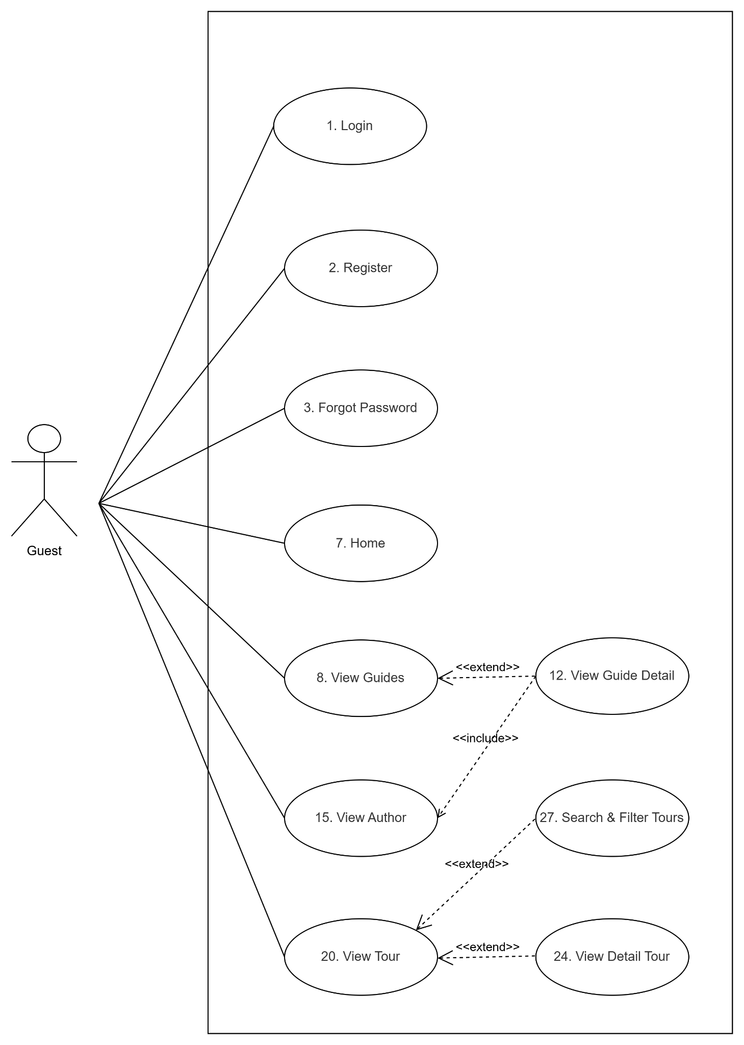

1.3.3.2 UCs for Customer
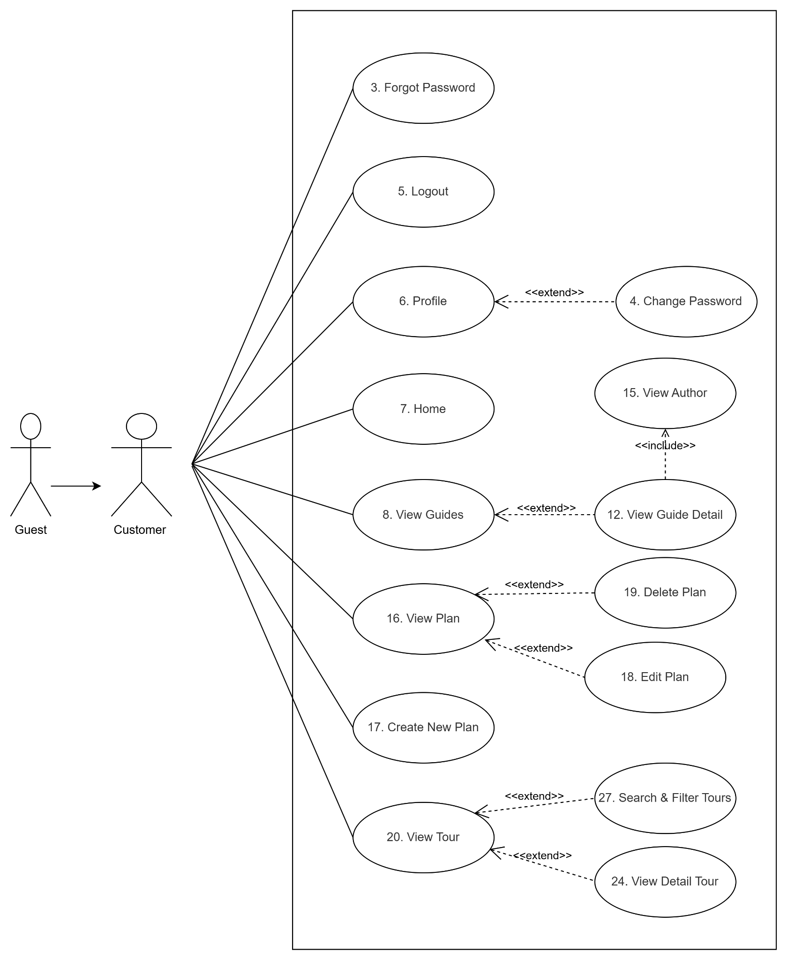

1.3.3.3 UCs for Admin
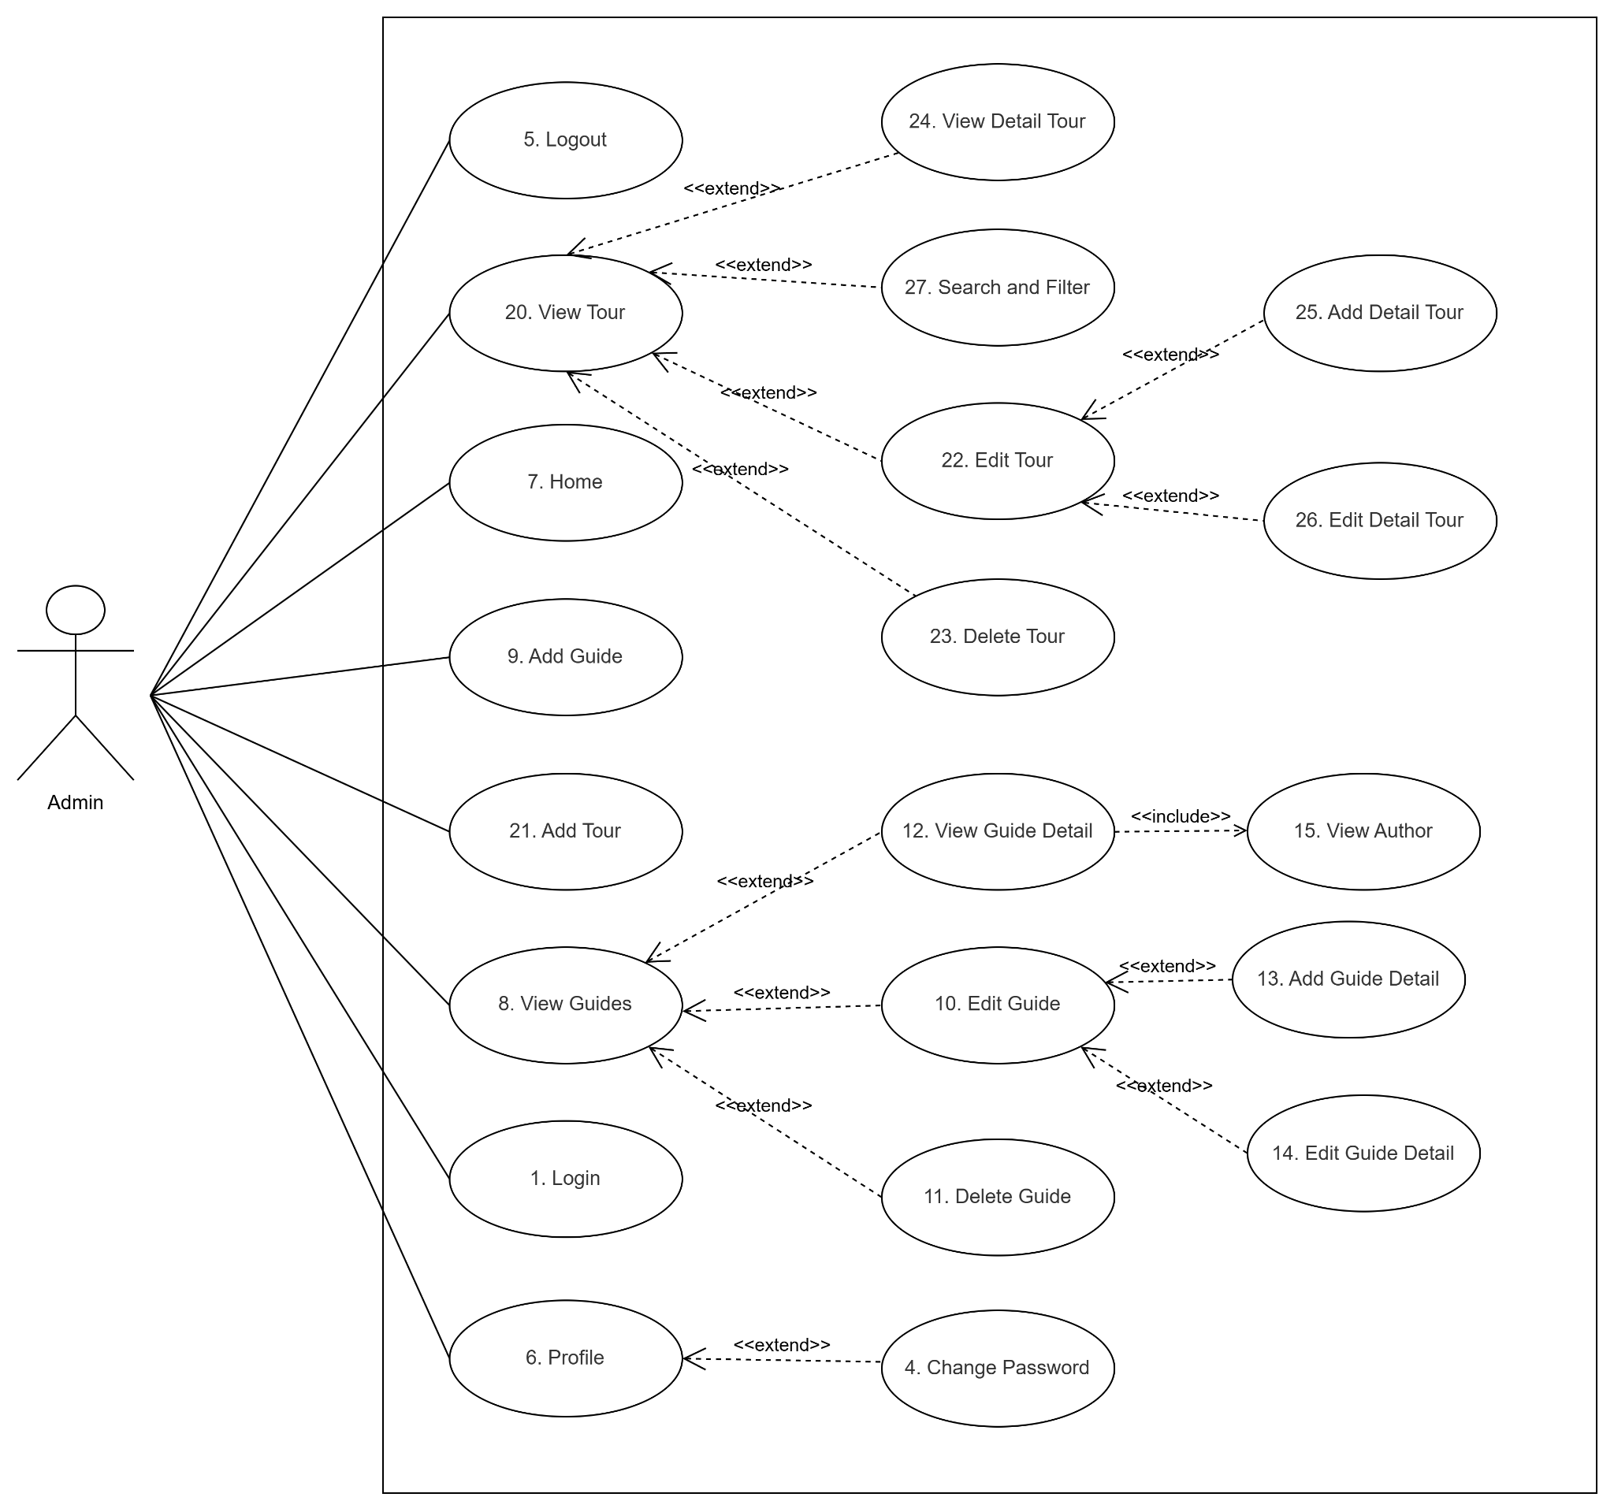

1.4 System Functionalities

1.4.1 Screens Flow
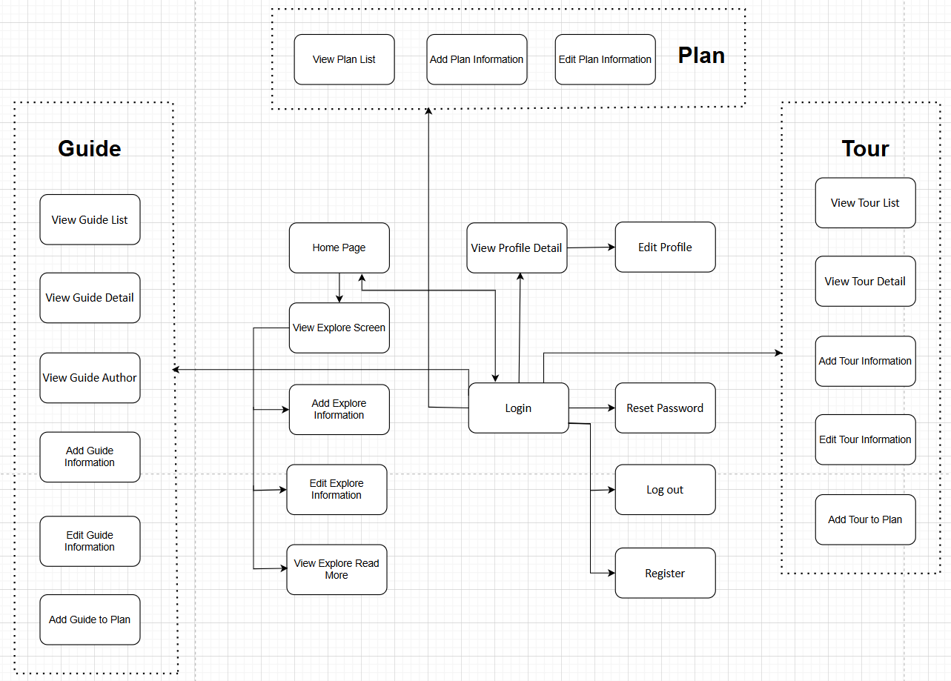

1.4.2 Screen Authorization
# | Screen | Admin | Customer | Guest
1 | Home Page | X | X | X
2 | View Explore Screen | X | X | X
3 | Add Explore Information | X
4 | Edit Explore Information | X
5 | View Explore Read More | X | X | X
6 | Register | X | X
7 | Login | X | X
8 | Logout | X | X
9 | Reset Password | X | X
10 | View Profile Detail | X | X
11 | Edit Profile | X | X
12 | View Guide List | X | X | X
13 | View Guide Detail | X | X | X
14 | View Guide Author | X | X | X
15 | Add Guide Information | X
16 | Edit Guide Information | X
17 | Add Guide to Plan | X | X
18 | View Tour List | X | X | X
19 | View Tour Detail | X | X | X
20 | Add Tour Information | X
21 | Edit Tour Information | X
22 | Add Tour to Plan | X | X
23 | View Plan List | X | X
24 | Add Plan Information | X | X
25 | Edit Plan Information | X | X

1.4.3 Non-UI Functions
# | Feature | System Function | Description
1 | User Password Encryption | Encrypt User Password | Encrypt user passwords after registration for Admin and Customer accounts
2 | Email Verification Link Generation | Generate Verification Link | Generate a unique authentication link and email it to the user after registration
3 | Password Reset Link Generation | Generate Reset Password Link | Generate a unique password reset link and send it via email when a user forgets their password
4 | Google Account Integration | Authenticate Google Account | Authenticate users signing in with their Google accounts through external Google authentication service

1.5 Entity Relationship Diagram
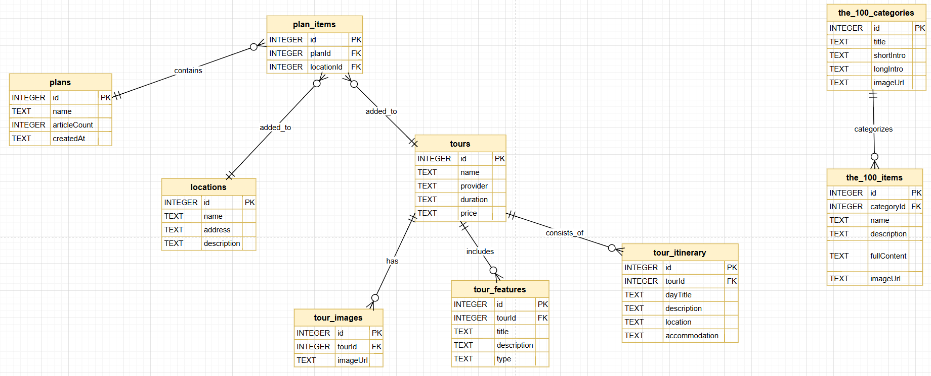

Entities Description
# | Entity | Description
1 | Plans | It stores information about user-created travel plans, including the plan name, the number of saved locations, and the creation time.
2 | Locations | Contains detailed information about landmarks and tourist destinations, such as addresses, descriptions, images, and classification by continent.
3 | Plan Items | The middleware manages the relationship between Plans and Locations, allowing users to add multiple locations to a specific plan.
4 | Tours | The primary entity stores information about tours, including the provider, price, duration, general itinerary, and operational information (group size, age,...)
5 | Tour Images | Store a list of additional images for each tour to display in the detailed photo gallery.
6 | Tour Itinerary | Contains detailed daily itinerary information for a tour, including day titles, activity descriptions, stopover locations, and accommodation options.
7 | Tour Features | Describe the highlights or included amenities of the tour (e.g., insurance, transportation, tour guide).
8 | The 100 Categories | The "Top 100" lists contain general introductory information and representative images of each category.
9 | The 100 Items | Store specific items belonging to a "Top 100" category, including place names, detailed descriptions, and full content for users to explore.

2. Use Case Specifications

2.1 Admin & Customer Features

2.1.1. Login

ID and Name | UC01 - Login
Created by | Nguyễn Văn Đức
Primary Actor | Admin | Secondary Actor | Customer
Description | User logs into the application using email/password or a Google account to access personalized features.
Preconditions | The application has been launched and is on the Login screen.
Main Sequence | 1. User enters Email and Password (or selects "Continue with Google").  2. System authenticates credentials via Firebase.  3. System checks user role (Admin/Customer) and saves Token.  4. System redirects user directly to the Guides Screen.
Alternative Sequences | 1a. User selects "Continue without login": System navigates directly to Guides Screen with Guest role.  2a. Invalid credentials: System displays an error message.
Post conditions | User is successfully logged in and has access to the Guides list.
Business Rule | None

2.1.2. Register

ID and Name | UC02 - Register
Created by | Nguyễn Văn Đức
Primary Actor | Admin | Secondary Actor | Customer
Description | New users create accounts on the registration page via the login or profile screen.
Preconditions | User is on the Register screen.
Main Sequence | 1. User enters Full Name, Email, Password, and Confirm Password.  2. User taps the "Register" button.  3. System sends account creation request to Firebase.  4. System displays a success message and redirects to the Login screen.
Alternative Sequences | 3a. Email already exists or password is not in the correct format.: System displays a specific error message.
Post conditions | A new user account has been created in the system.
Business Rule | None

2.1.3. Forgot Password

ID and Name | UC03 - Forgot Password
Created by | Nguyễn Văn Đức
Primary Actor | Admin | Secondary Actor | Customer
Description | User requests a password reset via email when they cannot remember their current password.
Preconditions | User is on the Forgot Password screen.
Main Sequence | 1. User enters their registered Email address.  2. System sends a Reset Password request to Firebase.  3. Firebase sends an email containing a password reset link to the user.  4. System notifies the user to check their inbox.
Alternative Sequences | 2a. Email does not exist: System displays an error "Email not found".
Post conditions | A password recovery email has been successfully sent.
Business Rule | None

2.1.4. Change Password

ID and Name | UC04 - Change Password
Created by | Nguyễn Văn Đức
Primary Actor | Admin | Secondary Actor | Customer
Description | User changes their current password to a new one to improve account security.
Preconditions | The user is logged in and has accessed the profile screen.
Main Sequence | 1. User enters current password, new password, and confirms the new password.  2. System verifies the current password and checks that the new passwords match.  3. System updates the new password on Firebase.  4. System displays a success message.
Alternative Sequences | 2a. Current password is incorrect or confirmation does not match: System displays an error.
Post conditions | The user's password has been successfully changed.
Business Rule | None

2.1.5. View Profile

ID and Name | UC06 - View Profile
Created by | Nguyễn Văn Đức
Primary Actor | Admin | Secondary Actor | Customer
Description | User views personal information, app settings, and a list of downloaded articles.
Preconditions | User is logged in and has selected the "Profile" tab on the Navigation Bar.
Main Sequence | 1. User navigates to the Profile screen.  2. System retrieves information from Firebase (Name, Avatar, Email) and SharedPreferences to display.  3. System displays options: Settings, Change Password, Downloaded Articles, Rate Our App, Logout.
Alternative Sequences | 1a. Guest access: System displays a "Login" button and an invitation to sign in.
Post conditions | The user's profile information is fully displayed.
Business Rule | None

2.1.6. View Guides

ID and Name | UC08 - View Guides
Created by | Nguyễn Văn Đức
Primary Actor | Admin | Secondary Actor | Customer
Description | User views the Guides tab and browses guide articles displayed by categories.
Preconditions | 1) User has entered the application (after login or as guest).  2) SQLite data is available in locations table.
Main Sequence | 1. User opens the Guides tab.  2. System queries guide-related data from SQLite via provider/repository.  3. System displays sections (Food & Drink, Guides & Tips, Culture) as horizontal cards with image, title, and short description.  4. User scrolls to browse guides.  5. User taps a card to open Guide Detail screen.
Alternative Sequences | A1. No data found -> System shows empty state (or no card list).  A2. Data loading error -> System shows error message.
Post conditions | Guide list is displayed successfully, and selected guide can be opened in detail view.
Business Rule | All users can view guides; only Admin has permission for add/edit/delete actions on guide content.

2.1.8. Update guide

ID and Name | UC0 - Update Guides
Created by | Đỗ Đắc Huy
Primary Actor | Admin | Secondary Actor | none
Description | Admin updates an existing guide article (name, address, description, image, category/type, continent).
Preconditions | 1) User has entered the application.  2) User role is Admin.  3) The selected guide already exists in SQLite (locations table).
Main Sequence | 1. Admin opens Guides tab and chooses a guide item.  2. Admin clicks Edit icon.  3. System opens Update form with existing data pre-filled.  4. Admin edits fields and clicks Save.  5. System validates input (required fields, continent selected).  6. System updates record in SQLite (UPDATE locations WHERE id = ?).  7. System refreshes provider/state and displays updated guide list.
Alternative Sequences | A1. Invalid input (empty required field / no continent) -> System shows validation error and does not save.  A2. Record not found / DB error -> System shows error message and keeps old data.
Post conditions | Guide data is updated successfully in SQLite and reflected immediately in Guides UI.
Business Rule | Only Admin can update guide data. id of guide must remain unchanged.

2.1.9. Delete Guides

ID and Name | UC0 - Delete Guides
Created by | Đỗ Đắc Huy
Primary Actor | Admin | Secondary Actor | none
Description | Admin deletes an existing guide article from the system.
Preconditions | 1) User has entered the application.  2) User role is Admin.  3) Guide exists in SQLite (locations).
Main Sequence | 1. Admin opens Guide Detail screen of a selected guide.  2. Admin clicks Delete icon.  3. System shows confirmation dialog.  4. Admin confirms deletion.  5. System removes related plan_items entries and updates plans.articleCount.  6. System deletes guide from locations.  7. System refreshes providers and returns to previous screen with success message.
Alternative Sequences | A1. Admin cancels confirmation -> System closes dialog, no data changed.  A2. DB error during delete -> System shows error message, guide remains unchanged.
Post conditions | Guide is removed from SQLite and no longer appears in Guides list. Related plan links are cleaned up.
Business Rule | Only Admin can delete guides. Deleting a guide must keep plan data consistent (plan_items cleanup + articleCount update).

2.1.10. View Author Detail

ID and Name | UC08 - View Author Detail
Created by | Đỗ Đắc Huy
Primary Actor | Admin | Secondary Actor | Customer
Description | User opens and views author profile details from Guide Detail screen.
Preconditions | 1) User has entered the application.  2) User is on Guide Detail screen.
Main Sequence | 1. User opens a guide article.  2. User taps author section/card.  3. System navigates to Author Detail screen.  4. System displays author data: avatar, name, role, age, country, hobbies, bio, life view, countries visited.
Alternative Sequences | A1. Author image cannot load -> System displays fallback icon/placeholder.  A2. Author data unavailable -> System shows default sample author data.
Post conditions | Author Detail screen is displayed successfully; no database change occurs.
Business Rule | View-only use case; no write operation. In current app version, author data is static (Author.sampleAuthor), not from SQLite.

2.3 Plan Location

2.3.1. View Plan List

ID and Name | UC09 - View Plan List
Created by | Trần Ngọc Dũng
Primary Actor | User | Secondary Actor | None
Description | User views the list of all personal travel plans they have created.
Preconditions | User is logged in with a valid account.
Main Sequence | 1. User navigates to the Plan section from the menu.  2. System retrieves and displays all plans associated with the user's account.  3. User reviews the list of plans.
Alternative Sequences | None.
Post conditions | User has successfully viewed their plan list.
Business Rule | BR-04: User must be 18 years of age

2.3.2. Add Plan Information

ID and Name | UC010 - Add Plan Information
Created by | Trần Ngọc Dũng
Primary Actor | User | Secondary Actor | None
Description | User creates a new travel plan by entering plan details.
Preconditions | User is logged in with a valid account.
Main Sequence | 1. User selects the "Add Plan" option.  2. System displays the plan creation form.  3. User fills in plan details (name, destination, date, notes).  4. User confirms by clicking "Save".  5. System saves the new plan and returns to the Plan List screen.
Alternative Sequences | If required fields are missing, the system displays a validation error and prompts the user to complete the form.
Post conditions | A new plan has been successfully created and saved to the user's account.
Business Rule | BR-04: Customers must be 18 years of age

2.3.3. Delete Plan

ID and Name | UC011 - Delete Plan Information

Created by | Trần Ngọc Dũng
Primary Actor | User | Secondary Actor | None
Description | User deletes an existing travel plan from their account.
Preconditions | User is logged in. At least one plan exists in the user's account.
Main Sequence | 1. User selects a plan from the Plan List.  2. User clicks the "Delete" option.  3. System displays a confirmation dialog.  4. User confirms the deletion.  5. System permanently removes the plan and updates the Plan List.
Alternative Sequences | If the user cancels the confirmation dialog, the system returns to the Plan List without deleting.
Post conditions | The selected plan has been permanently deleted from the user's account.
Business Rule | BR-04: A plan can only be edited by the user who created it

2.4 Tour Management Features
2.4.1 View Tour
ID and Name | UC20 - View Tour
Created by | Nguyễn Hoàng Việt
Primary Actor | Guest | Secondary Actor | Customer, Admin
Description | User views a list of available tours categorized by region or continent
Preconditions | The application is launched and the user is on the Home or Tour screen.
Main Sequence | 1. User selects the "Tours" tab.  2. System retrieves the list of active tours from the database.  3. System displays the tours grouped by region/continent.
Alternative Sequences | None.
Post conditions | User can see the list of available tours.
Business Rule

2.4.2 Add Tour
ID and Name | UC21 - Add Tour
Created by | Nguyễn Hoàng Việt
Primary Actor | Admin | Secondary Actor | None
Description | Admin creates a new tour package and uploads images from the gallery.
Preconditions | Admin is logged in and is on the Tour Management screen.
Main Sequence | 1. Admin clicks "Add New Tour".  2. System displays the Add Tour form.  3. Admin enters tour details (title, overview, region) and selects images.  4. Admin clicks "Save".  5. System validates the input and saves data.  6. System displays a success message and updates the list.
Alternative Sequences | 5a. Missing required fields: System highlights empty fields and prompts Admin to fill them.
Post conditions | A new tour is added and visible to all users.
Business Rule | Tour title and region are required fields.

2.4.3 Edit Tour
ID and Name | UC22 - Edit Tou
Created by | Nguyễn Hoàng Việt
Primary Actor | Admin | Secondary Actor | None
Description | Admin modifies general information or changes images of an existing tour.
Preconditions | Admin is logged in and viewing the Tour Management screen.
Main Sequence | 1. Admin selects a tour and clicks "Edit".  2. System displays the form populated with current tour data.  3. Admin updates text or images.  4. Admin clicks "Save Changes".  5. System validates and updates the database.  6. System shows a success message.
Alternative Sequences | 5a. Invalid input: System displays an error message
Post conditions | The tour's general information is successfully updated.
Business Rule | Tour title and region are required fields.

2.4.4 Delete Tour
ID and Name | UC23 - Delete Tour
Created by | Nguyễn Hoàng Việt
Primary Actor | Admin | Secondary Actor | None
Description | Admin permanently removes a tour from the system.
Preconditions | Admin is logged in and on the Tour Management screen.
Main Sequence | 1. Admin selects a tour and clicks "Delete".  2. System displays a confirmation dialog warning about data loss  3. Admin confirms the deletion.  4. System removes the tour from the database.  5. System shows a success message.
Alternative Sequences | 3a. Admin cancels: System closes the dialog and no changes are made.
Post conditions | The tour is permanently removed from the system.
Business Rule | Deleting a tour also deletes all its associated detail itineraries.

2.4.5 View Detail Tour
ID and Name | UC24 - View Detail Tour
Created by | Nguyễn Hoàng Việt
Primary Actor | Guest | Secondary Actor | Customer, Admin
Description | User views the specific itinerary, daily schedule, and images of a selected tour.
Preconditions | User is on the Tour List screen.
Main Sequence | 1. User clicks on a specific tour card.  2. System retrieves the detailed itinerary and highlights from the database.  3. System navigates to the Tour Detail screen and displays the information. |
Alternative Sequences | 2a. Connection error: System displays an error message and a retry button.
Post conditions | User can read the full detailed itinerary of the tour.
Business Rule | None

2.5 Explore
2.5.1 Add Explore
ID and Name | UC24 - Add Explore Item
Created by | Nguyễn Tiến Duy
Primary Actor | Admin | Secondary Actor | None
Description | Admin modifies general information or changes images of an existing tour.
Preconditions | Admin is logged in and on the Explore Management screen.
Main Sequence | 1. Admin clicks "Add New".  2. System displays an empty form.  3. Admin enters title, description, location, category, and uploads images.  4. Admin clicks "Save".  5. System validates input and saves data to database.  6. System confirms success and shows new item in list.
Alternative Sequences | 5a. Invalid input: System displays error message.  5b. Missing required fields: System prompts to complete required fields.
Post conditions | A new explore item is added and visible to users.
Business Rule | Title, category, and at least one image are required.

2.5.2 Edit Explore
ID and Name | UC25 - Edit Explore Item
Created by | Nguyễn Tiến Duy
Primary Actor | Admin | Secondary Actor | None
Description | Admin modifies existing explore item details or updates images.
Preconditions | Admin is logged in and viewing the Explore Management screen.
Main Sequence | 1. Admin selects an explore item and clicks "Edit".  2. System displays form with current data.  3. Admin updates text or images.  4. Admin clicks "Save Changes".  5. System validates and updates database.  6. System shows success message.
Alternative Sequences | 5a. Invalid input: System displays error message.
Post conditions | The explore item is updated successfully.
Business Rule | Title and category must not be empty.

2.5.3 Delete Explore
ID and Name | UC25 - Delete Explore Item
Created by | Nguyễn Tiến Duy
Primary Actor | Admin | Secondary Actor | None
Description | Admin removes an explore item from the system.
Preconditions | Admin is logged in and on the Explore Management screen.
Main Sequence | 1. Admin selects an explore item and clicks "Delete".  2. System asks for confirmation.  3. Admin confirms deletion.  4. System removes item from database.  5. System shows success message.
Alternative Sequences | 3a. Admin cancels deletion: System closes confirmation dialog without changes.
Post conditions | The explore item is permanently removed from the system.
Business Rule | Deletion is irreversible; confirmation is required.

2.5.4 The More Explore
ID and Name | UC26 - View Explore Item Details
Created by | Nguyễn Tiến Duy
Primary Actor | User | Secondary Actor | None
Description | User views full details of an explore item, including description, images, location, and related content.
Preconditions | User is browsing the Explore section.
Main Sequence | 1. User clicks on an explore item card.  2. System navigates to detail page.  3. System displays full description, images, category, location, and related items.  4. User scrolls or interacts with content.
Alternative Sequences | 3a. Item not found: System displays "Content not available" message.
Post conditions | User sees complete information about the selected explore item.
Business Rule | Detail page must show all relevant metadata and at least one image.

3. Non-Functional Requirements

3.1 External Interfaces
The Culture Trip application integrates the following external interfaces to ensure seamless connectivity between users, the system, and third-party services:
- Authentication Services: Supports user login and registration via Google Authentication API. When online, data is synchronized with Firebase; when offline, information is stored locally via SQLite.
- Firebase Realtime Database / Firestore: Synchronizes user profiles and favorites in real time when a network connection is available.
- SQLite (Local Storage): Stores offline data for profiles, plans, and cached content — ensuring an uninterrupted experience when the network is unavailable.
- Email Services: A third-party email service handles account verification and system notifications.

3.2 Quality Attributes

3.2.1 Usability
Efficiency: Admin can update guide or tour content in under 3 steps.
Easy to Learn: New users can create their first travel plan within 10 minutes without any guidance.
Accessibility: Responsive interface optimized for mobile (Android/iOS); complies with basic accessibility standards (contrast ratio, minimum font size).
Theme & Language: Users can switch between Dark/Light mode and language (EN/VI) in Settings without reloading the app.

3.2.2 Reliability
Availability: System uptime of 99.9%.
Data Integrity: Bidirectional Firebase ↔ SQLite synchronization ensures no data loss when switching between online and offline states. Data is backed up daily.
Offline Resilience: When the network is unavailable, the app continues to function using cached SQLite data and automatically re-syncs when connectivity is restored.
Fault Tolerance: A queue mechanism for emails handles interruptions from external email service providers.

3.2.3 Performance
Response time:
- Tour and guide search results: < 2 seconds.
- Plan, guide detail, and tour detail updates: < 1 second.
- Firebase re-sync upon returning online: < 5 seconds.
Load capacity:
- Supports 1,000 concurrent users.
- Supports 100 simultaneous tour booking transactions.

3.2.4 Security
Data Security: All communications are encrypted via TLS. Passwords are hashed using a strong algorithm (bcrypt or Argon2).
Access Control: Strict RBAC — clear permission levels for Guest, Customer and Admin roles, following the principle of least privilege.
Vulnerability Prevention: Protection against common vulnerabilities including SQL Injection, XSS, and CSRF.
Offline Data Protection: Data stored in SQLite is encrypted at the application layer.

4. Requirement Appendix

4.1 Business Rules
ID | Rule Definition
BR-01 | Users must be 18 years of age or older to book a tour.
BR-02 | Only tours with status "Available" may be booked.
BR-03 | Each tour must have at least one guide assigned before it can be published.
BR-04 | A plan can only be edited by the user who created it.
BR-05 | Explore The 100 content may only be added or edited by an Admin or Author.
BR-06 | A guide detail must belong to an existing guide in the system.
BR-07 | The default application language is English; users may change it in Settings.
BR-08 | Profile data is synced via Firebase when online; stored locally via SQLite when offline.

4.2 Common Requirements
4.2.1 General Requirements
Phone number: 10–11 digits, starting with 0.
Email: must contain the @ character and a valid domain name.
ID card / CCCD number: 9 or 12 digits.
Guide / tour / plan name: minimum 3 characters, maximum 150 characters.
Description field: maximum 2,000 characters.
Uploaded images: JPG, PNG, or WEBP format; maximum 5 MB per image.

4.2.2 Data Requirements
Phone number: 10–11 digits, starting with 0.
Email: must contain the @ character and a valid domain name.
ID card / CCCD number: 9 or 12 digits.
Guide / tour / plan name: minimum 3 characters, maximum 150 characters.
Description field: maximum 2,000 characters.
Uploaded images: JPG, PNG, or WEBP format; maximum 5 MB per image.

4.2.3 Validation Requirements
All required fields must be marked with * and validated before submitting the form.
The system must check vehicle availability before confirming the booking.

4.3 Application Messages List
# | Message code | Message Type | Context | Content
1 | MSG02 | Error | No results found | "No tours or guides were found matching your criteria. Please try different filters."
2 | MSG03 | Error | Required field blank | "The [Field Name] field is required. Please enter information."
3 | MSG04 | Warning | Tour unavailable | "The tour you selected is no longer available. Please choose another tour or date."
4 | MSG05 | Error | Login failed | "Email or password is incorrect. Please try again."
5 | MSG06 | Success | Registration successful | "Account registration successful! A verification link has been sent to your email."
6 | MSG07 | Info | No plans yet | "You have no plans yet. Tap '+' to create your first travel plan.."
7 | MSG08 | Error | System error | "A system error has occurred. Please try again later."
8 | MSG09 | Success | Update successful | "Information updated successfully!"
9 | MSG10 | Error | Offline mode | "You are offline. Some features may be limited. Data is saved locally."
10 | MSG11 | Error | Guide has no details | This guide has no details yet. Please add guide details before publishing.
11 | MSG12 | Success | Added to plan | Added to your plan successfully!

III. Software Design

1. High Level Design

1.1 Software Architecture
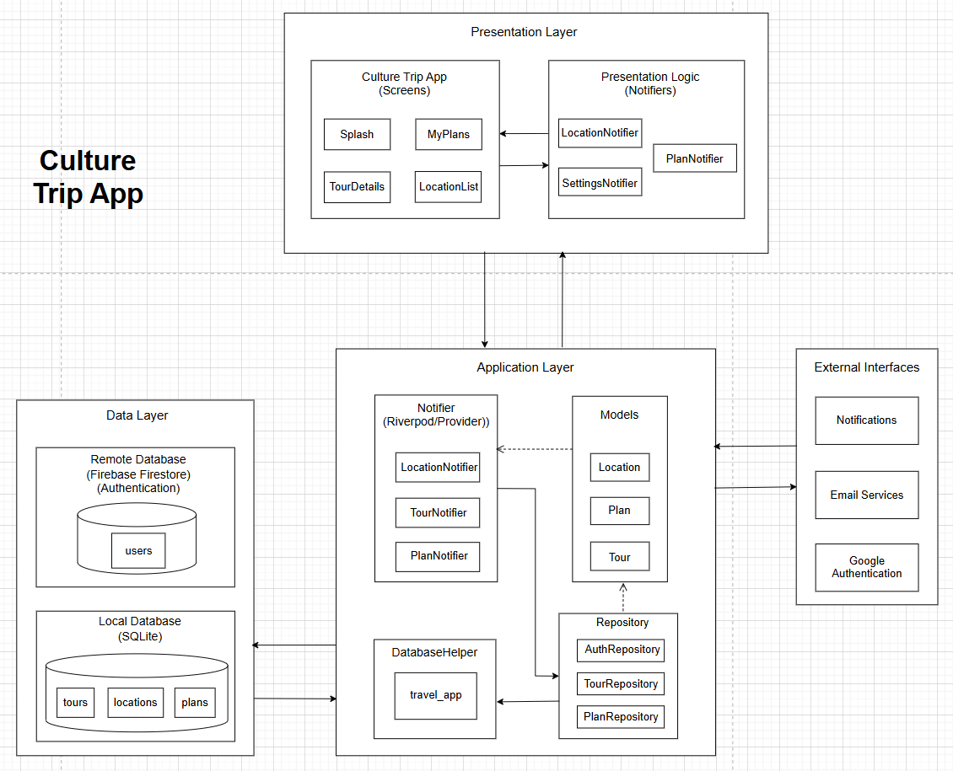

1.2 Package Diagram

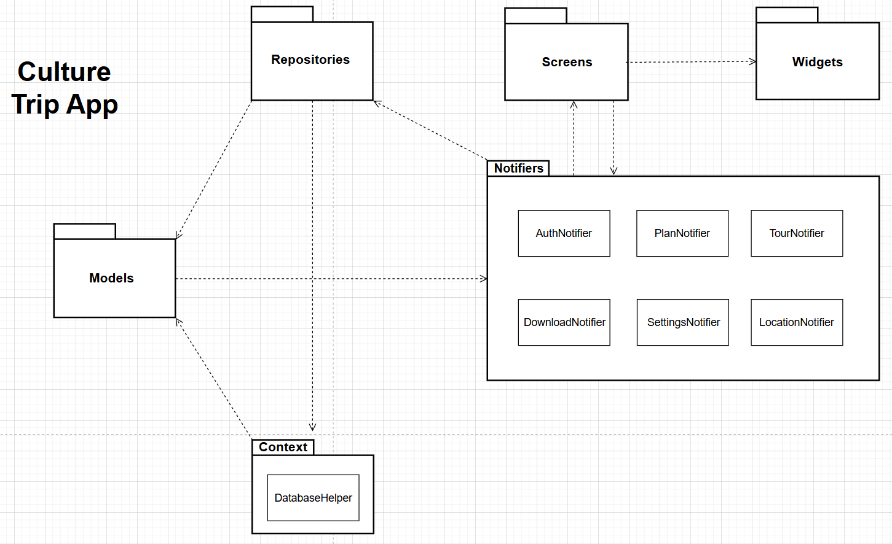

Package Descriptions
No | Package | Description
01 | Models | Contains Domain Model classes (Location, Tour, User, Plan) representing travel business objects, used to map with tables in the SQLite database.
02 | Repositories | The Data Access Object layer, responsible for performing CRUD operations with SQLite and authenticating users through Firebase Auth.
03 | Notifiers | The state management layer using Riverpod, handles business logic, receives user interactions, and coordinates data flow between the UI and Repositories.
04 | Context | Manages SQLite database initialization, defines the Schema (table structure), handles version upgrades, and maintains a single Singleton connection throughout the application.
05 | Widgets | Contains reusable UI components such as input forms, custom buttons, and utility functions that support data formatting and notification display.
06 | Screens | The Presentation Layer consists of the main application screens (Login, Guides, Tours, My Plans, Profile) responsible for rendering the UI and receiving user input.

2. Database Design

2.1 Database diagram
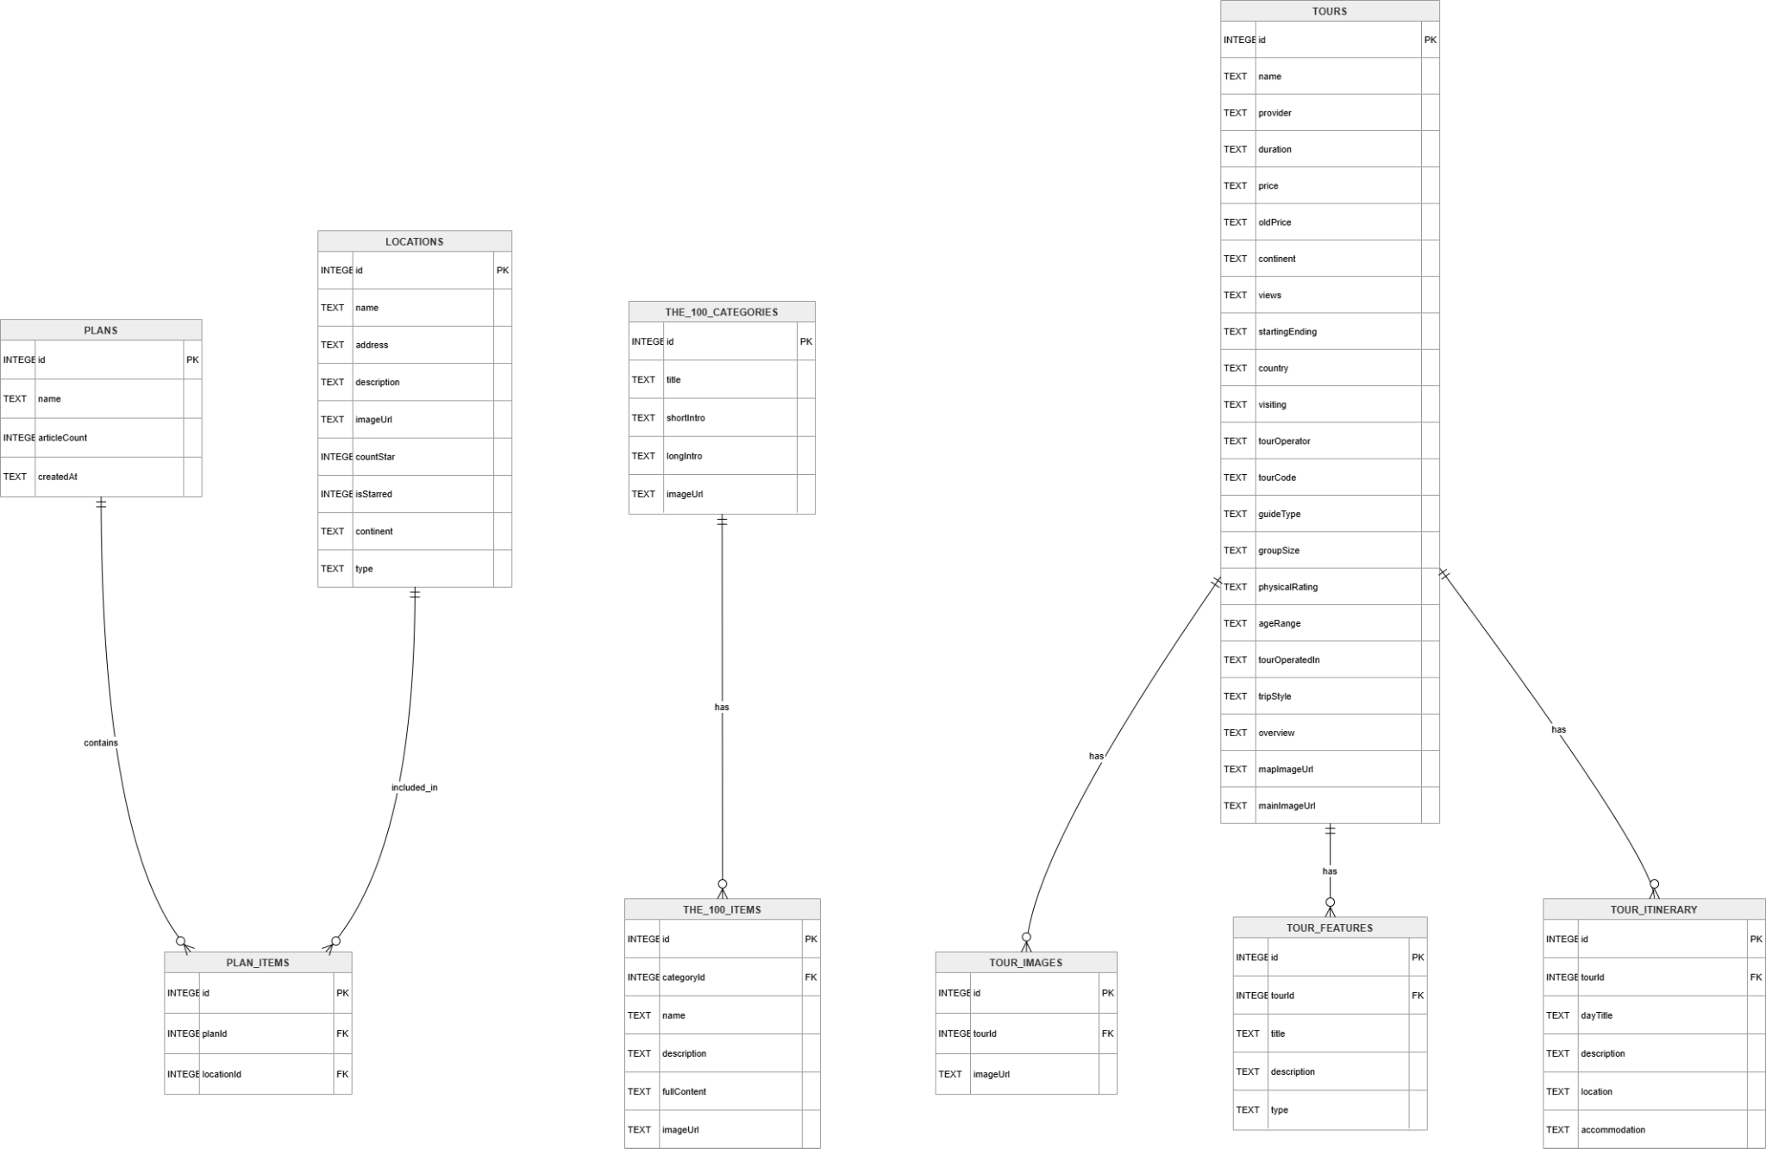

2.2.Table Descriptions

2.2.1 locations
This table stores information about locations/articles displayed on the app (e.g., city, Food & Drink, Guides & Tips, Culture), used for the Home tab, Guides, and detail screens.
No | Field | PK | FK | UN | NN | Description
01 | id | ✓ |  |  | ✓ | Unique identifier of the location (assigned by the application when adding new data or seeding data).
02 | name |  |  |  | ✓ | The display name of the location or post.
03 | address |  |  |  | ✓ | The address or a string describing the location (usually in the format “City, Country”).
04 | description |  |  |  | ✓ | Content description/summary.
05 | imageUrl |  |  |  | ✓ | Image path (asset or URL depending on how it's used in the UI).
06 | countStar |  |  |  | ✓ | Number of ratings / stars (integer).
07 | isStarred |  |  |  | ✓ | Favorite status (0 or 1 in the DB).
08 | continent |  |  |  | ✓ | The continent/region code is used for filtering (matching the category in the app).
09 | type |  |  |  | ✓ | Content type: `food`, `guides_tips`, `culture`, `city`, … (can be NULL if not assigned).

2.2.2 plans
This table stores the user's travel plans (My Plans), including the plan name, creator, and number of posts/locations added.
No | Field | PK | FK | UN | NN | Description
01 | id | ✓ |  |  | ✓ | The plan's self-incrementing primary key.
02 | name |  |  |  | ✓ | The display name of the plan.
03 | userId |  |  |  | ✓ | User identifier (usually Firebase UID or an empty string if not logged in — according to app logic).
04 | articalCount |  |  |  | ✓ | The number of items added to the plan (updated when adding/removing `plan_items`).
05 | createdAt |  |  |  | ✓ | Time of creation (ISO 8601 series).

2.2.3. Plan_items
The table shows many-to-many relationships between plans and locations: each row indicates a location belonging to a plan.
No | Field | PK | FK | UN | NN | Description
01 | id | ✓ |  |  | ✓ | The self-incrementing primary key of the link line.
02 | planId |  | ✓ |  | ✓ | Reference plan; deleting the plan will cause CASCADE to remove the related lines.
03 | locationId |  | ✓ |  | ✓ | Reference location; removing the location will cause CASCADE to remove the link.

2.2.4 the_100_categories
The list includes entries for "The 100" (title, short/long description, featured photo).
No | Field | PK | FK | UN | NN | Description
01 | id | ✓ |  |  | ✓ | Unique identifier for contact record.
02 | title |  |  |  | ✓ | References the customer being contacted.
03 | shortIntro |  |  |  | ✓ | Type of customer (e.g., new, VIP, inactive).
04 | longIntro |  |  |  | ✓ | Contact email used.
05 | imageUrl |  |  |  | ✓ | Full name of customer.

2.2.5 tours
This table stores shipping/delivery details for orders.
No | Field | PK | FK | UN | NN | Description
01 | id | ✓ |  |  | ✓ | The main course is an optional extra for the tour.
02 | name |  |  |  |  | Tour name.
03 | provider |  |  |  |  | Organizer / label “by …”.
04 | duration |  |  |  |  | Duration (e.g., “8 days”).
05 | continent |  |  |  |  | Continent / Region.
06 | views |  |  |  |  | View count display sequence (demo).
07 | startingEnding |  |  |  |  | Start/end point (if any).
08 | country |  |  |  |  | Nation.
09 | visiting |  |  |  |  | Describe the attractions.
10 | tourOperator |  |  |  |  | Tour operator.
11 | tourCode |  |  |  |  | Tour code.
12 | guideType |  |  |  |  | Type of instructions (e.g., Fully Guided).
13 | groupSize |  |  |  |  | Group size.
14 | physicalRating |  |  |  |  | Fitness level.
15 | ageRange |  |  |  |  | Suitable age range.
16 | tourOperatedIn |  |  |  |  | Operating language.
17 | tripStyle |  |  |  |  | Travel style.
18 | overview |  |  |  |  | Overview of content.
19 | mapImageUrl |  |  |  |  | Map image.
20 | mainImageUrl |  |  |  |  | Tour profile picture.
21 | price |  |  |  |  | Price displayed (string).

2.2.6 tour_features
This table stores customer feedback on cars or services.
No | Field | PK | FK | UN | NN | Description
01 | id | ✓ |  |  | ✓ | The primary key increments automatically.
02 | tourId |  | ✓ |  |  | Corresponding tour; CASCADE when canceling the tour.
03 | title |  |  |  |  | Section Title.
04 | description |  |  |  |  | Detailed description
05 | type |  |  |  |  | Feature type (e.g. highlighted / included / not Included)

IV. Implementation

4.1. Login Flow
- Step 1: The user accesses the login page and enters their account credentials.
- Step 2: The system checks the validity of the login information and access permissions.
- Step 3: If successful, the user is directed to the homepage according to their role 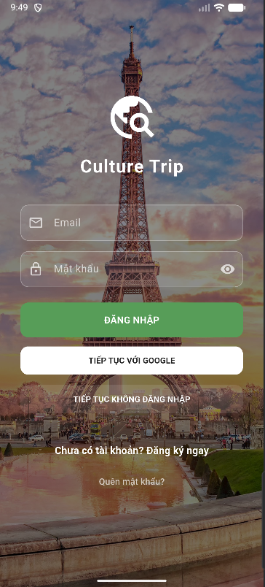

4.2. Homepage and Viewing Tour List
- Step 1: The user selects the "Tour List" option from the menu to view the list of available tours.
- Step 2: The system displays a list of Tours with details such as Tour name, type, location and availability.

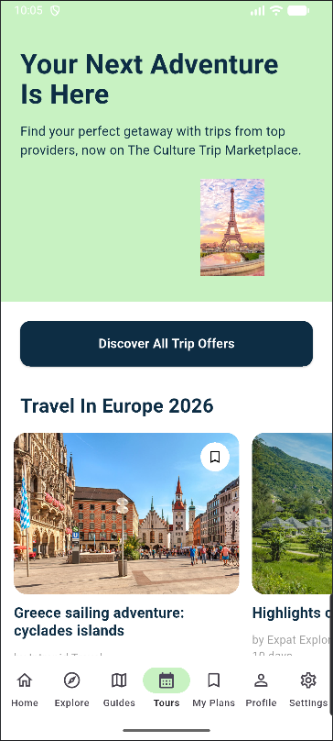

4.3. Tour Detail
- Step 1: The user clicks on a Tour to view more information.
- Step 2: The system displays the tour's details, along with the relevant description, duration, and included highlights.

- 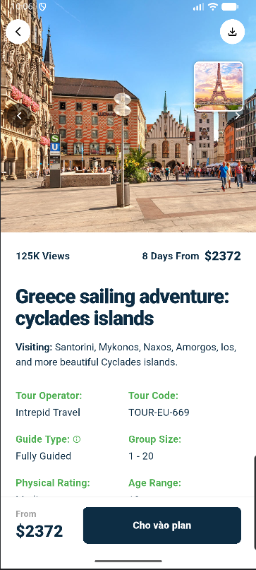

4.4. Add Tour to Plan

- Step 1: The system prompts the user to add the selected tour to an existing Plan or create a new one.
- Step 2: The user selects a Plan and confirms. The tour is saved to the Plan.
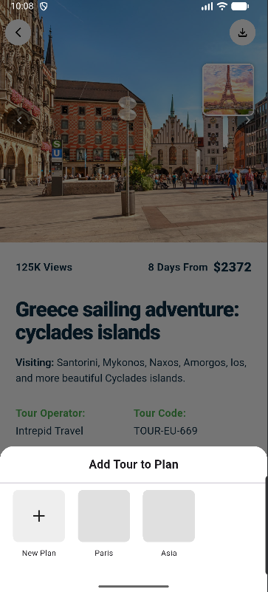

4.5. Tour Completion
- The tour has been successfully added to the user's Plan and is available for offline viewing. The system sends a confirmation notification to the user.

